Catrina Hill

Exhibition Assistant Curator

Peabody Essex Museum

East India Square

Salem, MA 01970 USA

Telephone: [978-542-1614](tel:978-542-1614)

Fax: [978-744-6776](tel:978-744-6776)

Email: [catrina_hill@pem.org](mailto:catrina_hill@pem.org)

**Douglas, Aaron ( 1899-1979) Word Count: 500**

Aaron Douglas was an African American artist and educator often referred to as the father of “Black Art.” He was a leading figure of the artistic movement known as the Harlem Renaissance. Douglas is best known for his work of the 1920s and 30s, which featured abstracted silhouettes combined with African tribal art and ancient Egyptian profile heads. European artists like Matisse, Modigliani and Picasso had been influenced by African tribal art for decades, but Douglas was among the first African American artists to blend African art with modern abstraction. Douglas produced illustrations for such magazines as *The Crisis*, *Survey Graphic* and *Opportunity* along with co-founding the short-lived *Fire!! A Quarterly Journal Devoted to the Younger Negro Artists.* He also illustrated books by several well-known literary figures, including Alain Locke, James Weldon Johnson, Langston Hughes, Countee Cullen, and Claude McKay. He is recognised for several public murals, including the *Birth o' the Blues* at the Sherman Hotel in Chicago, *Evolution of Negro Dance* at the Harlem YMCA, and *Aspects of Negro Life* at the 135th Street Branch of the New York Public Library. As a professor of fine art Douglas encouraged generations of African American artists to create their own modern Black aesthetic.

Douglas was born on May 26, 1899 in Topeka, Kansas, where his working-class family could not provide financial support for his education. After graduating from Topeka High School in 1917, Douglas took on several jobs to earn money for college. He began studying art at the University of Nebraska, Lincoln in the fall of 1917, but his studies were interrupted by military service in World War I. Returning to Lincoln after the War he completed his bachelor of fine arts degree in 1922. He later earned a Master’s Degree from Columbia University. Douglas moved to New York City in 1925, initially as a stopover on his way to Paris, and quickly became a leading figure in the Harlem Renaissance. During the Great Migration, millions of African Americans relocated to Northern cities like New York in search of jobs and a better life. Harlem became the de-facto center of the African American community in New York, and was a mecca for black artists, musicians, writers and performers in the 1920s and 30s. Douglas studied with German artist Fritz Winold Reiss for two years. As a proponent of finding inspiration in one’s heritage and experiences, Reiss encouraged Douglas to utilise influences from African art in his work. In 1938 Douglas accepted a position as Assistant Professor at Fisk University, a historically black college in Nashville, Tennessee where he taught until 1966. Douglas died in Nashville February 2, 1979.

**References and further reading**

Earle, S., ed. (2007) *Aaron Douglas: African American Modernist*, New Haven: Yale University Press; Lawrence: Spencer Museum of Art, University of Kansas.

Kirschke, A. H. (1995) *Aaron Douglas: Art, Race, and the Harlem Renaissance*. Jackson: University Press of Mississippi, 1995.

Powell, R. J. (Spring/Summer 2008) “Paint that Thing! Aaron Douglas’s Call to Modernism,” American Studies, Vol. 49, No. 1/2, pp. 107-119.

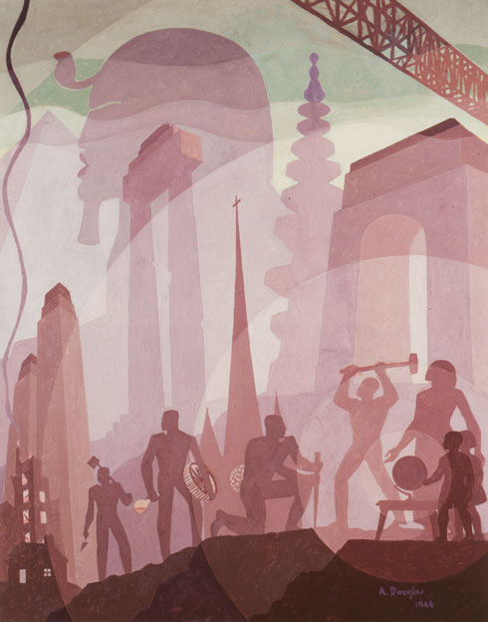

Aaron Douglas

Building More Stately Mansions, 1944

Oil on canvas

54 x 42 inches (137.2 x 106.7 cm)

Fisk University Galleries, Nashville

© VAGA New York

<http://www.fisk.edu/services-resources/fisk-university-galleries/the-aaron-douglas-gallery>